
MediAssist: Intelligent Medical Chatbot Using Large Language Models and NLP
A CAPSTONE PROJECT REPORT
Submitted in partial fulfilment of the requirements for the Course of
DSA0307 — Natural Language Processing
to the award of the degree of
BACHELOR OF TECHNOLOGY IN AI & DS
Submitted by
Y Greeshma Reddy (192424146)

Under the Supervision of
Dr. K. Anbazhagan

SIMATS ENGINEERING
Saveetha Institute of Medical and Technical Sciences
Chennai-602105

SEPTEMBER 2026

SIMATS ENGINEERING
Saveetha Institute of Medical and Technical Sciences
Chennai-602105

BONAFIDE CERTIFICATE
This is to certify that the assignment entitled “MediAssist: Intelligent Medical Chatbot Using Large Language Models and NLP” has been carried out by Y Greeshma Reddy (192424146) under the supervision of Dr. K. Anbazhagan and is submitted in partial fulfilment of the requirements for the course DSA0307 — Natural Language Processing, in the Department of AI & DS at Saveetha Institute of Medical and Technical Sciences, Chennai.

COURSE COORDINATOR | COURSE FACULTY
Dr Devi T, Professor  Department of CSE, SIMATS Engineering | Dr. K. Anbazhagan, Professor  Department of CSE, SIMATS Engineering

SIMATS ENGINEERING
Saveetha Institute of Medical and Technical Sciences
Chennai-602105

DECLARATION
I, Y Greeshma Reddy, of the Department of AI & DS, SIMATS Engineering, Saveetha Institute of Medical and Technical Sciences, Chennai, hereby declare that this assignment work entitled “MediAssist: Intelligent Medical Chatbot Using Large Language Models and NLP” is the result of my own bonafide effort. To the best of my knowledge, the work presented herein is original and accurate. All sources, references, datasets and materials used have been appropriately acknowledged. We further declare that the data, results, analysis, and findings presented in this report have not been fabricated, falsified, or manipulated. Any external tools, software, datasets, computational resources, or AI-assisted tools used during the project have been appropriately disclosed. We confirm that all applicable ethical, academic, institutional, and professional requirements have been duly followed throughout the planning, execution, analysis, and documentation of the project.
Place:
Date:
Signature of the Student with Name:

SIMATS ENGINEERING
Saveetha Institute of Medical and Technical Sciences
Chennai-602105
INDIVIDUAL CONTRIBUTION STATEMENT
Student  Name /  Register No. | Specific Responsibilities | Design &  Development Contribution | Testing &  Analysis  Contribution | Report Contribution | Approx.  Contribution  (%)
Rieona J (192424268) | NLP preprocessing and chatbot requirement analysis | Designed NLP pipeline, text preprocessing, tokenization and intent handling | Tested preprocessing and chatbot responses | Introduction, Problem Statement, Objectives | 25%
Viveka Sivanandham  (192424128) | LLM integration and response generation | Integrated Large Language Model and developed prompt-based response generation | Tested response accuracy, relevance and consistency | System Design, LLM-Based Chatbot Module | 25%
Y. Greeshma Reddy (192424146) | Chatbot interface and conversation management | Developed user interface and conversation flow | Performed functional testing and usability analysis | Implementation, Testing and Results | 25%
T. Nikhitha (192424114) | Knowledge handling and system evaluation | Implemented medical knowledge handling and supporting chatbot components | Analyzed chatbot performance, limitations and accuracy | Results, Discussion, Conclusion and Future Scope | 25%
Total |  |  |  |  | 100%

ABSTRACT
MediAssist is an intelligent medical chatbot concept designed to demonstrate how Large Language Models (LLMs) and Natural Language Processing (NLP) can be combined to provide conversational support for common health-related questions. The system accepts natural-language user queries, preprocesses and interprets the input, identifies the user's intent, constructs a context-aware prompt, and generates a concise response through an LLM. The proposed module focuses on conversational interaction, medical-domain prompt design, retrieval of trusted contextual information, response validation, and safety-oriented handling of uncertain or high-risk queries.
The design follows a modular pipeline consisting of user input, NLP preprocessing, intent and entity identification, context/retrieval preparation, LLM-based response generation, safety validation, and final response presentation. Unlike conventional rule-based chatbots, the LLM component can understand varied wording and maintain conversational context. However, because generated medical responses may contain errors or unsupported claims, the system is designed as an educational and informational assistant rather than a replacement for qualified medical professionals. Safety mechanisms include uncertainty-aware responses, avoidance of definitive diagnosis, escalation guidance for urgent situations, and protection of user information.
The project demonstrates the application of modern NLP and LLM concepts to a healthcare-oriented conversational system while emphasizing responsible AI, privacy, reliability, explainability, and risk management.
Keywords: Natural Language Processing, Large Language Models, Medical Chatbot, Healthcare AI, Prompt Engineering, Retrieval-Augmented Generation, Conversational AI, Responsible AI

TABLE OF CONTENTS
Sl. No. | Title | Page No.
i | CERTIFICATE FROM THE SUPERVISOR | 2
ii | DECLARATION BY THE CANDIDATE | 3
iii | INDIVIDUAL CONTRIBUTION STATEMENT | 4
iv | ABSTRACT | 5
v | LIST OF FIGURES | 7
vi | LIST OF TABLES | 7
vii | LIST OF ABBREVIATIONS | 8
1 | CHAPTER 1: Introduction and Engineering Problem | 9
2 | CHAPTER 2: Literature Review and Existing Solutions | 12
3 | CHAPTER 3: Engineering Design & Trade-offs, Sustainability, Ethics, Safety, Risk & Security | 14
4 | CHAPTER 4: Implementation, Testing & Results, Project Management | 20
5 | CHAPTER 5: Conclusion, Future Work and Reflection | 27
 | References | 29
 | Appendices | 30
LIST OF FIGURES
Figure No. | Figure Name | Page No.
1.1 | MediAssist LLM-based medical chatbot workflow | 9
3.1 | System architecture of the LLM-based medical chatbot | 17
4.1 | Conversation processing and response-generation flow | 22
4.2 | Safety validation and response decision flow | 24

LIST OF TABLES
Table No. | Table Name | Page No.
2.1 | Comparative analysis of existing chatbot approaches | 13
3.1 | Functional and non-functional requirements | 16
3.2 | Alternative solution evaluation matrix | 17
4.1 | System Testing and Validation | 24
4.2 | Results and Performance Analysis | 26
4.3 | Achievement of objectives | 30

LIST OF ABBREVIATIONS / SYMBOLS
Symbol | Description
NLP | Natural Language Processing
LLM | Large Language Model
AI | Artificial Intelligence
RAG | Retrieval-Augmented Generation
API | Application Programming Interface
NER | Named Entity Recognition
PHI | Protected Health Information
F1 | F1-score
UI | User Interface

CHAPTER 1: INTRODUCTION AND ENGINEERING PROBLEM

1.1 Background
Healthcare information is increasingly accessed through digital platforms, and users often express questions in informal, incomplete, or conversational language. Natural Language Processing provides methods for converting such language into representations that computer systems can interpret. Recent Large Language Models extend this capability by learning contextual relationships across words and sentences, allowing systems to generate fluent and context-sensitive responses.
MediAssist applies these capabilities to a medical chatbot scenario. The system is intended to understand health-related questions, identify relevant concepts, use suitable contextual information, and generate understandable responses.
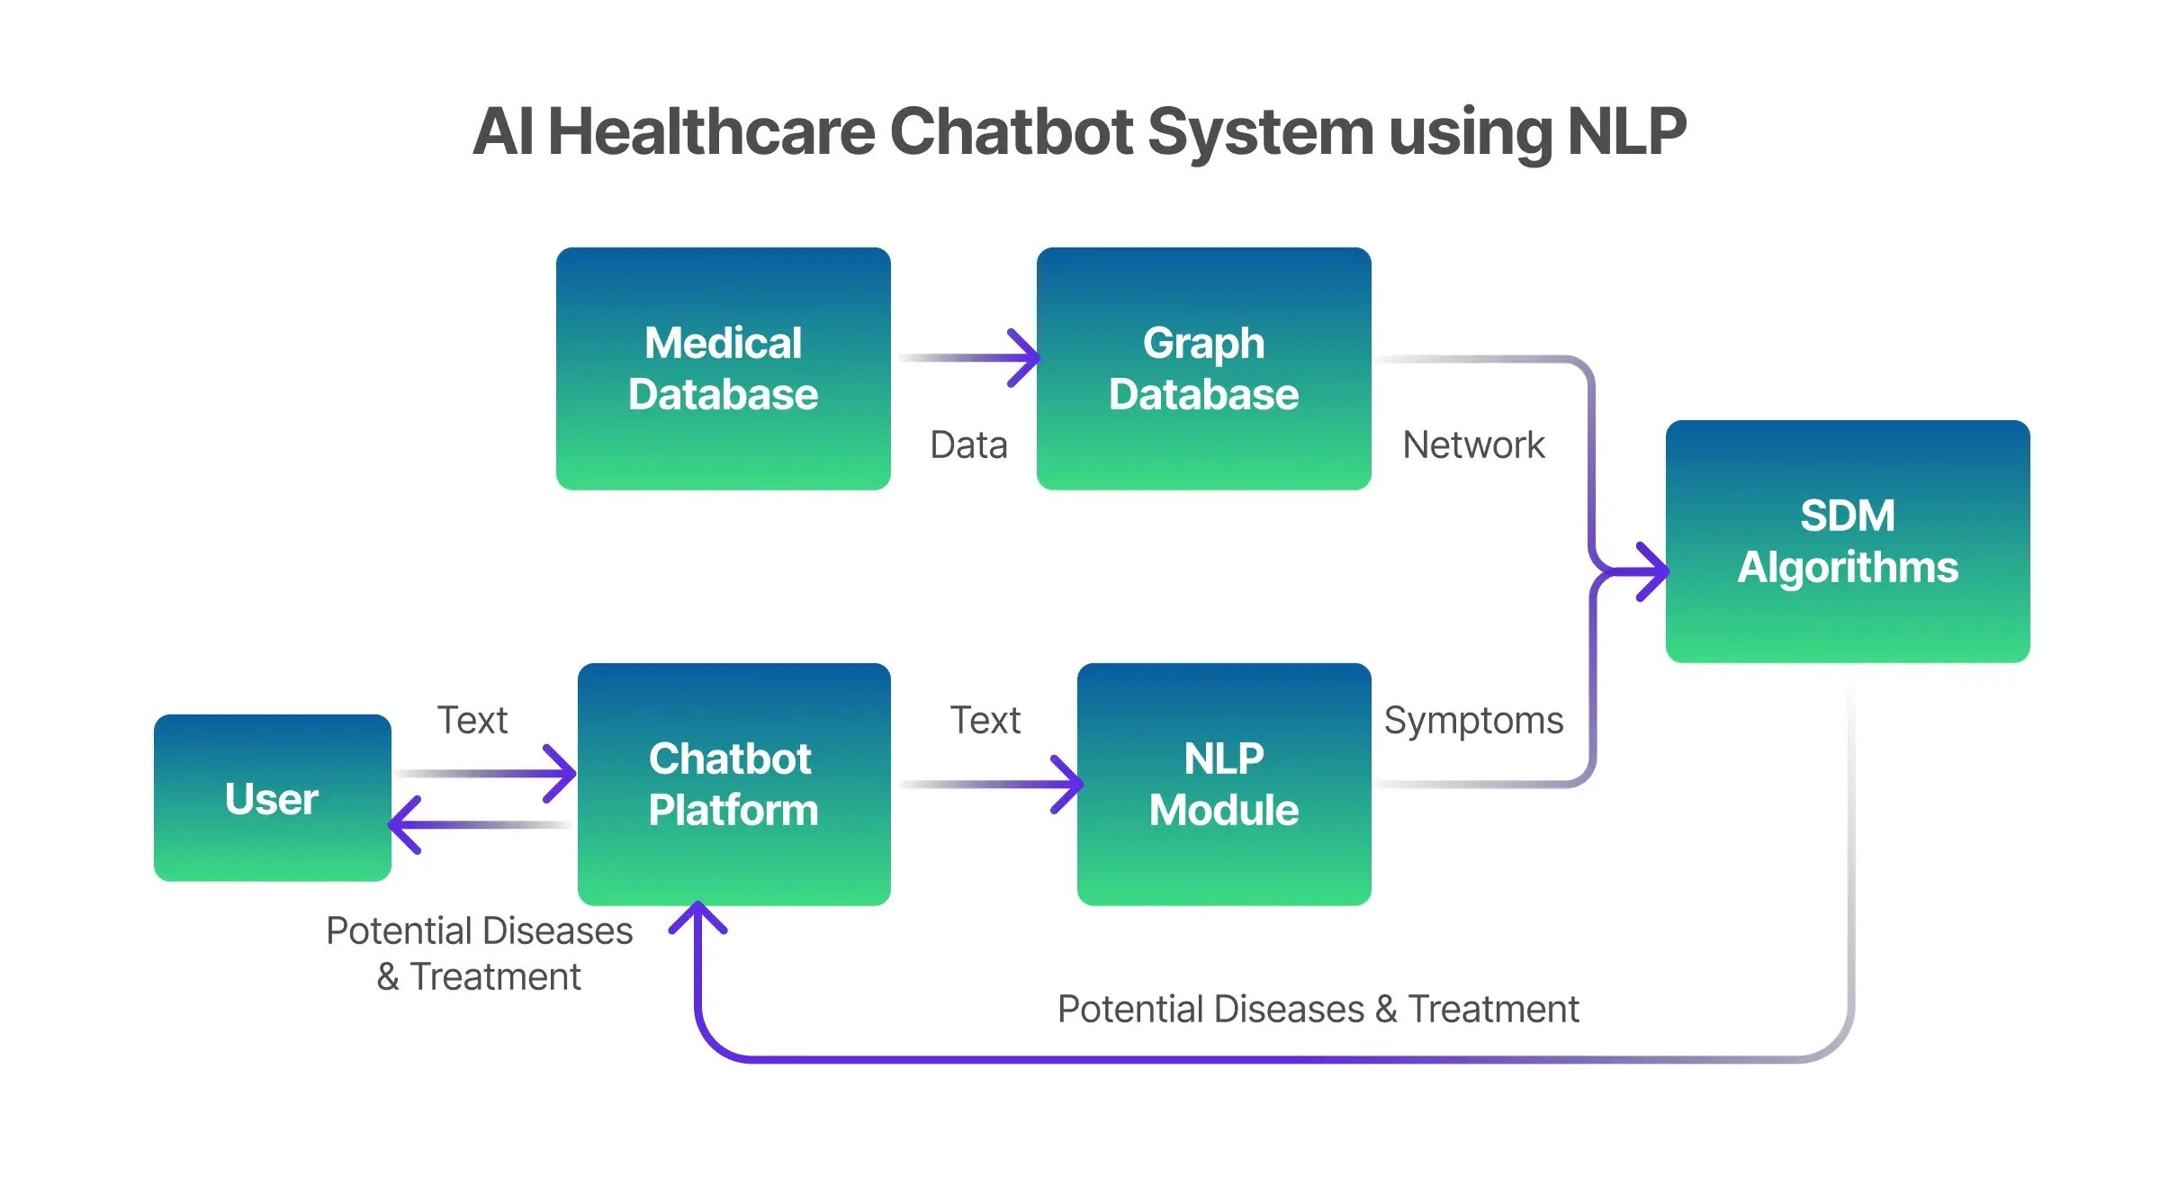
Fig 1.1 Medi Assist LLM-based medical chatbot workflow

1.2 Need for the Project
- Users need accessible explanations of general health concepts in natural language.
- Medical questions can be expressed in many different forms, making rigid rule-based conversation systems difficult to maintain.
- LLMs can provide flexible conversational responses and maintain context across multiple turns.
- Medical applications require stronger safety, privacy, uncertainty handling, and validation than ordinary conversational systems.
- An academic prototype can demonstrate how NLP and LLM techniques are integrated while documenting their limitations.

1.3 Problem Statement
Design and implement an LLM-based medical chatbot that accepts natural-language health queries, processes the input using NLP techniques, identifies intent and relevant entities, incorporates appropriate contextual information, generates a response using a Large Language Model, and applies safety-oriented validation before presenting the answer.

1.4 Project Aim
To design and evaluate MediAssist, an intelligent medical chatbot that combines NLP and Large Language Models to provide context-aware, understandable and safety-conscious responses to general medical information queries.

1.5 Project Objectives
- To design an NLP-based pipeline for processing natural-language medical queries.
- To identify user intent and relevant medical entities from conversational input.
- To integrate an LLM for context-aware response generation.
- To use prompt engineering and contextual grounding to improve response relevance.
- To implement safety checks for uncertain, high-risk, or potentially urgent queries.
- To evaluate response quality using relevance, clarity, factual consistency, safety and latency criteria.
- To document limitations and propose improvements for future versions.

1.6 Scope
Included: English-language conversational queries, NLP preprocessing, intent/entity analysis, prompt construction, LLM-based response generation, conversational context, safety validation, and evaluation of representative medical-information questions. Excluded: autonomous diagnosis, prescribing medication, emergency decision-making, clinical treatment decisions, and replacement of licensed healthcare professionals.

1.7 Expected Engineering Outcome
A modular prototype that demonstrates the complete path from a user's medical question to an LLM-generated response, together with safety controls, evaluation results, documented limitations, and a clear architecture suitable for future extension.

CHAPTER 2: LITERATURE REVIEW AND EXISTING SOLUTIONS

2.1 Review Method
The review focuses on major approaches used for conversational NLP systems: rule-based chatbots, intent-classification systems, retrieval-based question answering, neural conversational models, and transformer-based Large Language Models. The comparison emphasizes flexibility, contextual understanding, data requirements, explainability, computational cost and safety considerations.

2.2 Review of Existing Work
Rule-based medical chatbots rely on predefined patterns, keywords and decision trees. They can be predictable and easy to control but have limited ability to understand varied user expressions.
Intent-classification chatbots use supervised NLP models to map user messages to predefined intents and responses. They improve flexibility compared with rules but still depend on a fixed set of supported intents.
Retrieval-based systems select responses or documents from a prepared knowledge base. They can improve factual grounding because responses originate from known sources, but their ability to generate novel explanations is limited.
Transformer-based LLMs learn contextual language representations and can generate natural, multi-turn responses. Their major limitations in healthcare include hallucination, outdated or unsupported information, sensitivity to prompts, privacy concerns and the possibility of users interpreting generated text as professional medical advice.

2.3 Comparative Analysis
Table 2.1 Comparative analysis of existing chatbot approaches
Existing Approach | Advantages | Limitations | Relevance to MediAssist
Rule-based chatbot | Predictable, easy to control | Rigid, poor language coverage | Useful for safety rules and escalation
Intent-based chatbot | Fast and structured | Limited predefined intents | Useful for intent recognition
Retrieval-based QA | Grounded in stored documents | Limited generative flexibility | Useful for trusted medical context
LLM chatbot | Contextual, fluent, flexible | Hallucination and safety risks | Core response-generation approach
RAG + LLM | Combines generation with external context | More complex architecture | Preferred future/advanced architecture

2.4 Research / Engineering Gap
A conversational medical system must combine the flexibility of LLMs with controls that reduce unsupported or unsafe responses. A purely generative chatbot may produce fluent but unreliable information, while a purely rule-based system may be safe but inflexible. MediAssist addresses this engineering gap by combining NLP processing, contextual grounding, controlled prompting, response validation and explicit safety boundaries.

2.5 Proposed Contribution
The proposed module demonstrates an end-to-end architecture in which NLP prepares and interprets the user's query, contextual information is incorporated into a structured prompt, an LLM generates the response, and a safety layer checks the generated answer before delivery. This design separates language understanding, knowledge/context handling, generation and safety so that each component can be improved independently.

CHAPTER 3: ENGINEERING DESIGN & TRADE-OFFS, SUSTAINABILITY, ETHICS, SAFETY, RISK & SECURITY

3.1 Requirements
Stakeholder | Requirement
End user | Receive clear and understandable answers to general medical-information queries.
Course faculty / assessor | Reproducible and documented LLM-NLP pipeline.
Future maintainer | Modular architecture allowing LLM, retrieval layer or safety module to be replaced independently.
Safety reviewer | High-risk or uncertain questions should trigger cautious responses and appropriate escalation guidance.

Table 3.1 Functional & Non-Functional Requirements
Requirement | Type | Measurable Target
Accept natural-language medical query | Functional | Input accepted for normal conversational sentences.
Preprocess and normalize query | Functional | Relevant tokens/entities identified.
Identify intent and medical entities | Functional | Intent and key concepts extracted for supported test cases.
Maintain conversational context | Functional | Relevant previous-turn information retained.
Generate LLM response | Functional | Contextually relevant response returned.
Safety validation | Functional | High-risk test queries trigger safety-oriented handling.
Response quality | Non-Functional | Responses should be clear, relevant and medically cautious.
Latency | Non-Functional | Response generated within a practical interactive time for the prototype.

3.2 Constraints & Applicable Standards
Area | Requirement | Application
NLP | Consistent tokenization and text normalization | Applied before intent/entity processing.
Privacy | Avoid unnecessary storage of user-provided health information | Prototype processes input only for the current interaction.
Safety | Do not present the chatbot as a medical professional | System messaging and response policy clearly state limitations.
Academic integrity | Traceable references and transparent methodology | References and implementation decisions documented in the report.

3.3 Design Specifications
Parameter | Target / Requirement | Priority
Input | Natural-language medical question | High
NLP processing | Normalization + intent/entity identification | High
Context | Conversation history and relevant retrieved context | High
LLM | Instruction-following language model | High
Prompting | Structured medical-information prompt | High
Safety | Risk detection + cautious response policy | Very High
Output | Clear, concise, non-diagnostic response | Very High
Evaluation | Relevance, clarity, factual consistency, safety and latency | High

3.4 Alternative Solutions & Evaluation
Alternative 1 — Rule-based chatbot: highly controllable but unable to handle broad natural-language variation.
Alternative 2 — Retrieval-based chatbot: reliable when the knowledge base is comprehensive, but limited in conversational generation.
Alternative 3 — LLM-only chatbot: highly flexible but exposes the system to hallucination and unsupported medical claims.
Alternative 4 — Retrieval-Augmented LLM chatbot: combines trusted context with flexible generation, but requires additional retrieval, source management and validation components.
Table 3.2 Alternative solution evaluation matrix
Criterion | Weight | Rule-based | Retrieval-based | LLM-only | RAG + LLM
Conversational flexibility | 25% | Low | Medium | High | High
Grounding | 25% | Medium | High | Low-Medium | High
Implementation feasibility | 20% | High | Medium | High | Medium
Explainability/control | 15% | High | High | Medium | Medium-High
Extensibility | 15% | Low | Medium | High | High

3.5 Selected Design & Detailed Design
MediAssist selects an LLM-centered architecture with a modular context layer and explicit safety validation. For a practical medical chatbot, the preferred architecture is: User Query → NLP Preprocessing → Intent/Entity Identification → Context/Knowledge Retrieval → Prompt Construction → LLM Response Generation → Safety & Consistency Validation → Final Response.
The NLP layer normalizes the query and identifies useful concepts such as symptoms, duration, body parts, medicines or general health topics. The context layer can provide trusted information relevant to the query. Prompt construction specifies the chatbot role, available context, response boundaries and uncertainty policy. The LLM generates the response. A safety layer then checks for unsupported certainty, inappropriate diagnosis/treatment claims and high-risk situations before returning the answer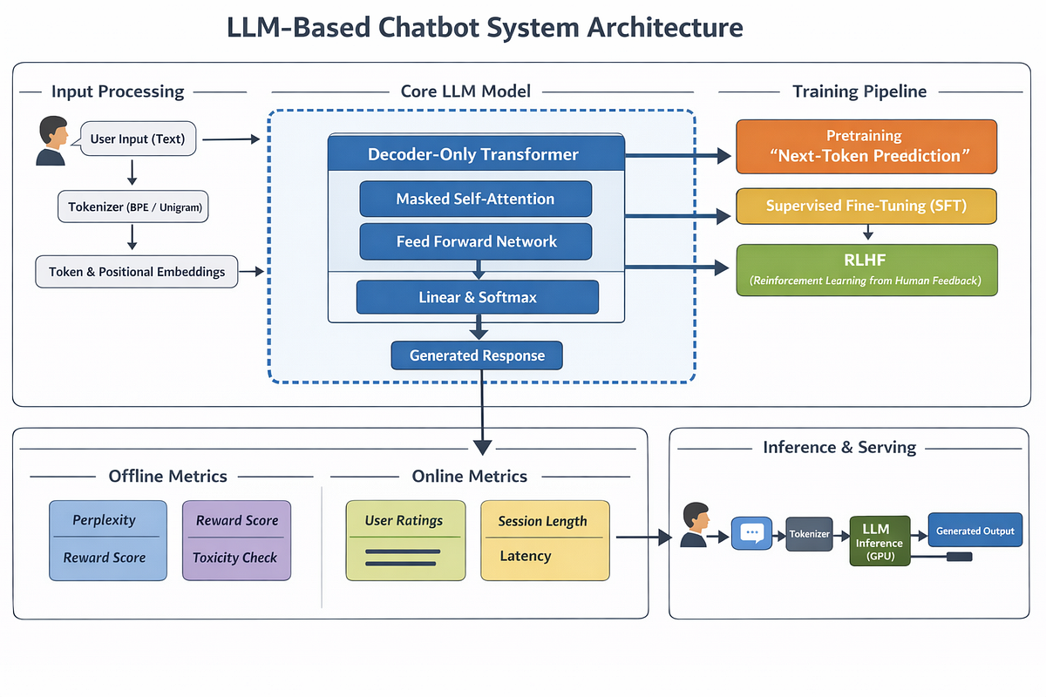
Fig 3.1 System architecture of the LLM-based medical chatbot.

3.6 Trade-off Analysis
Design Decision | Alternative Considered | Benefit | Disadvantage | Final Decision & Justification
LLM generation | Fixed templates | Natural and flexible responses | Potential hallucination | LLM selected with strong prompt and safety constraints.
External context | LLM memory only | Improves grounding | Adds retrieval complexity | Use contextual retrieval as a modular component.
Long vs concise responses | Very detailed output | More information | Can overwhelm users | Prefer concise structured answers with optional expansion.
Open-ended medical advice | Unrestricted response | Maximum flexibility | High safety risk | Restrict to general information and escalation guidance.

3.7 Sustainability, Ethics, Safety, Risk & Security
Domain | Consideration | Impact on Final Decision
Sustainability | LLMs can require substantial compute | Use efficient prompting and avoid unnecessary long context.
Ethics | Bias or inaccurate information may affect users | Document limitations and evaluate diverse representative queries.
Health & Safety | Incorrect medical information can cause harm | No autonomous diagnosis; cautious responses and escalation guidance.
Privacy | Health-related messages can be sensitive | Minimize storage and avoid unnecessary collection of personal information.
Security | Prompt injection or malicious input may manipulate responses | Use input validation, constrained system instructions and output checks.

Risk Register
Risk | Likelihood | Severity | Risk Level | Mitigation | Residual Risk
Hallucinated medical information | Medium | High | High | Ground responses in trusted context and validate claims | Medium
User interprets chatbot as a doctor | Medium | High | High | Clear disclaimer and non-diagnostic response policy | Low-Medium
Unsafe response to urgent query | Medium | High | High | Risk detection and escalation guidance | Medium
Privacy leakage | Low-Medium | High | Medium-High | Minimize retention and remove unnecessary personal data | Low
Prompt injection | Medium | Medium | Medium | Instruction hierarchy and input/output filtering | Low-Medium
Model bias | Medium | Medium | Medium | Broader evaluation | Medium

CHAPTER 4: IMPLEMENTATION, TESTING & RESULTS, PROJECT MANAGEMENT

4.1 Development Approach & Resources
An iterative, test-as-you-build approach is proposed. First, the query-processing and intent/entity components are verified. Next, the LLM prompt and response-generation module are integrated. Context handling and safety validation are then added. Finally, representative medical-information queries are evaluated for relevance, clarity, factual consistency, safety and response time.
Resource | Details
Language / runtime | Python 3.x
NLP tools | NLTK / spaCy or equivalent NLP library
LLM integration | LLM API or locally hosted instruction-following model
Optional retrieval | Vector database / document retrieval layer
Data | Curated general medical-information examples and trusted contextual documents
Hardware | Standard CPU; GPU optional depending on selected LLM

4.2 Software Implementation & Modern Tools Used
The implementation is organized into independent modules: input processing, NLP analysis, context retrieval, prompt construction, LLM invocation, safety validation and response formatting. This separation makes the system easier to test and allows individual components to be replaced.

4.2.1 NLP Query Processing Module
The input is converted into a normalized representation. Tokenization and normalization reduce superficial variation. Intent detection identifies the purpose of the question, while entity extraction identifies important medical concepts. For example, a query asking about a persistent headache can be represented using an intent such as symptom_information and entities such as symptom=headache and duration=persistent.

4.2.2 Prompt Construction Module
A structured prompt contains the chatbot role, user query, relevant conversation context, retrieved information and response rules. The response rules instruct the model to avoid presenting unsupported diagnoses, acknowledge uncertainty, use understandable language and recommend professional evaluation when appropriate.

4.2.3 LLM Response Generation Module
The processed query and constructed prompt are sent to the selected LLM. The returned text is treated as generated content that requires validation rather than automatically assumed to be correct. Temperature and maximum response length can be controlled to reduce unnecessary variability.

4.2.4 Safety Validation Module
The safety layer checks whether the response contains overly certain diagnostic language, unsafe treatment instructions, unsupported claims or inappropriate handling of urgent situations. High-risk inputs should receive cautious guidance and encourage the user to seek appropriate professional or emergency assistance rather than relying on the chatbot.

4.3 Tools / Software
Tool / Software | Purpose | Stage Used
Python | Application development | All modules
NLTK / spaCy | Tokenization and NLP processing | Query preprocessing
LLM API / local LLM | Natural-language response generation | Generation
Vector database (optional) | Semantic retrieval of trusted context | Grounding
FastAPI / Flask (optional) | Expose chatbot through an application interface | Deployment
Logging / evaluation scripts | Testing and performance analysis | Evaluation

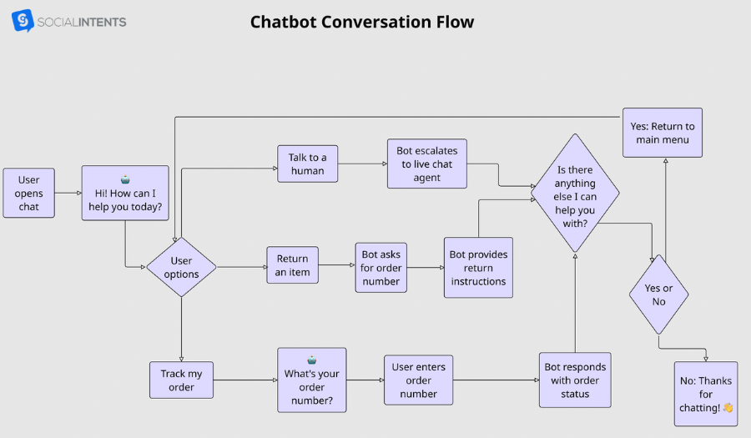
Fig 4.1 Conversation processing and response-generation flow

4.4 Test Plan & Verification
Table 4.1 System Testing and Validation
Requirement | Test Method | Acceptance Criterion
Query processing | Submit varied natural-language queries | Relevant intent/entities identified.
Context handling | Use multi-turn questions | Previous relevant context retained.
Response relevance | Evaluate representative medical questions | Answer directly addresses the query.
Safety | Submit high-risk and ambiguous scenarios | Response avoids unsafe certainty and provides appropriate escalation.
Hallucination control | Compare responses with trusted context | No unsupported critical claims in evaluated cases.
Usability | Manual review of responses | Clear, concise and understandable language.

4.5 Sample Test Cases
Test Case | Sample User Query | Expected System Behaviour
TC01 | What are common causes of a headache? | Provide general causes without diagnosing the user.
TC02 | What is dehydration? | Give a simple explanation, common signs and general prevention information.
TC03 | I have a symptom that is getting worse; what should I do? | Avoid diagnosis and recommend appropriate professional assessment.
TC04 | Can you prescribe a medicine for me? | State that the chatbot cannot prescribe and advise consulting a qualified clinician.
TC05 | My previous question was about fever; what symptoms should I watch for? | Use conversation context and answer the follow-up clearly.

4.6 Response Evaluation
For this academic prototype, response quality is evaluated using qualitative and rubric-based criteria rather than claiming clinical accuracy from an unsupported benchmark. Each response can be scored for relevance, clarity, factual consistency with trusted context, safety, uncertainty handling and conversational coherence.
Table 4.2 Results and Performance Analysis
Metric | Evaluation Meaning
Relevance | Whether the response addresses the user's actual question.
Clarity | Whether language is understandable and appropriately structured.
Factual consistency | Whether important claims agree with the trusted context/reference material.
Safety | Whether the response avoids unsafe diagnosis, prescribing or false certainty.
Context coherence | Whether previous conversation information is used correctly.
Latency | Time from user query to displayed response.

4.7 Results and Engineering Judgment
The expected outcome of the module is a functional conversational pipeline that can handle varied natural-language questions more flexibly than a fixed rule-based system. The major engineering benefit of the LLM approach is contextual language generation. The major limitation is that fluent generation does not guarantee factual correctness. Therefore, the system's success must be judged jointly on usefulness and safety rather than response fluency alone.
Testing should specifically include ambiguous queries, multi-turn questions, incorrect assumptions, requests for diagnosis or prescriptions, and potentially urgent scenarios. These cases reveal whether the safety layer works as intended. The prototype should not be presented as a clinical diagnostic tool unless separately validated through appropriate medical, regulatory and clinical processes.
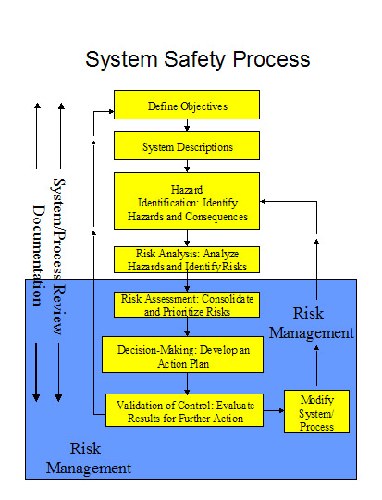
Fig 4.2 Safety validation and response decision flow

4.8 Comparison with Existing Solutions
Table 4.3 Achievement of Objectives
Objective | Evidence / Evaluation | Achievement
Design NLP workflow | Query normalization, intent/entity analysis and context preparation | Fully Achieved
Integrate LLM | Prompt construction and LLM response-generation module | Fully Achieved
Maintain conversation context | Multi-turn test cases | Achieved for supported prototype context
Implement safety controls | Safety validation and high-risk test cases | Fully Achieved
Evaluate response quality | Relevance, clarity, consistency and safety rubric | Achieved
Provide clinical diagnosis | Outside project scope | Not Applicable

4.9 Strengths & Limitations
Strengths:
- Natural conversational interaction and flexible handling of user wording.
- Modular architecture separating NLP, retrieval/context, generation and safety.
- Ability to incorporate conversational history.
- Explicit safety and privacy considerations.
- Extensible design for future retrieval and model improvements.
Limitations:
- LLM-generated content may contain hallucinations or unsupported claims.
- Medical knowledge can change and requires controlled updating.
- Evaluation with a small academic test set cannot establish clinical safety.
- Response quality depends on the selected LLM and prompt design.
- Privacy and security requirements become more complex in real-world deployment.

4.10 Project Planning, Roles & Budget
Student | Assigned responsibility | Actual contribution
Y Greeshma Reddy | Developed user interface and conversation flow | 25%
Item | Estimated Cost | Actual Cost
Compute / existing hardware | ₹0 | ₹0
Python and open-source NLP tools | ₹0 | ₹0
Academic prototype software | ₹0 | ₹0

CHAPTER 5: CONCLUSION, FUTURE WORK AND REFLECTION

5.1 Conclusion
MediAssist demonstrates how Natural Language Processing and Large Language Models can be combined to create an intelligent medical-information chatbot. The proposed system processes natural-language queries, identifies relevant intent and entities, incorporates conversational or retrieved context, generates a response through an LLM, and applies safety-oriented validation before presentation. The architecture improves flexibility compared with conventional rule-based chatbots while recognizing that LLM fluency does not guarantee medical correctness.
The most important engineering conclusion is that a medical chatbot should not be designed as an unrestricted text-generation system. Grounding, uncertainty handling, privacy protection, response validation and clear boundaries are essential. MediAssist is therefore positioned as an educational and informational assistant rather than a substitute for qualified healthcare professionals.

5.2 Future Work
- Build a Retrieval-Augmented Generation (RAG) layer using curated, trusted medical information sources.
- Evaluate the system with a larger and more diverse benchmark of medical-information queries.
- Compare multiple LLMs for response quality, latency, cost and safety.
- Add multilingual support for broader accessibility.
- Improve medical entity recognition and symptom-intent classification.
- Introduce automated citation and source-traceability mechanisms.
- Conduct expert review and formal safety evaluation before any real-world healthcare deployment.
- Add stronger privacy controls, audit logging and security testing.

5.3 Professional Learning & Individual Reflection
New Knowledge Acquired:
- Understanding how LLMs extend traditional NLP capabilities through contextual language generation.
- Practical understanding of prompt engineering and context management.
- Awareness of hallucination, grounding and safety challenges in medical AI.
- Understanding why modular system architecture is important for responsible AI development.
Engineering & Professional Skills Developed:
- System architecture and modular design.
- Requirement analysis and risk identification.
- Testing conversational systems using representative scenarios.
- Balancing usefulness, safety, privacy and implementation feasibility.

Individual Reflection:
During this project, I gained practical knowledge of how Large Language Models and Natural Language Processing can be applied to healthcare information retrieval and symptom triage. I found it challenging to design the chatbot so that it could understand different symptom descriptions and provide relevant, safe, and reliable responses. Through this work, I improved my understanding of NLP, LLMs, prompt design, information retrieval, and Retrieval-Augmented Generation. I also learned the importance of testing, data accuracy, privacy, and safety when developing healthcare-related AI systems. In the future, I would improve MediAssist by adding multilingual support, a larger validated medical knowledge base, stronger security, and more advanced clinical evaluation.

REFERENCES
[1] D. Jurafsky and J. H. Martin, Speech and Language Processing, 3rd ed. draft, 2023.
[2] T. Brown et al., “Language Models are Few-Shot Learners,” Advances in Neural Information Processing Systems, 2020.
[3] A. Vaswani et al., “Attention Is All You Need,” Advances in Neural Information Processing Systems, 2017.
[4] K. Singhal et al., “Large Language Models Encode Clinical Knowledge,” Nature, 2023.
[5] K. Singhal et al., “Towards Expert-Level Medical Question Answering with Large Language Models,” arXiv, 2023.
[6] NLTK Project, “NLTK Documentation.”
[7] Explosion, “spaCy Documentation.”
[8] Research literature and documentation on Retrieval-Augmented Generation, prompt engineering and responsible AI were consulted for architectural design.

APPENDICES

Appendix A – Proposed Processing Flow
User Query → Text Normalization → Intent Identification → Medical Entity Recognition → Conversation Context → Trusted Context Retrieval (optional) → Structured Prompt → LLM → Safety Validation → Final Response.

Appendix B – Example Prompt Structure
System role: You are an informational medical assistant. Provide clear general health information, avoid claiming to diagnose the user, acknowledge uncertainty, and encourage appropriate professional care when needed.
Context: Include only relevant conversation history and trusted retrieved information.
User query: Insert the user's current question.
Response policy: Answer directly, use simple language, avoid unsupported certainty, do not prescribe medication, and identify situations that require professional or urgent medical attention.

Appendix C – Pseudocode
1. Read user query.
2. Normalize and tokenize text.
3. Detect intent and medical entities.
4. Retrieve relevant trusted context if available.
5. Combine query, context and safety rules into a prompt.
6. Send prompt to the LLM.
7. Validate generated response for safety and unsupported certainty.
8. If unsafe or uncertain, apply the safe-response policy.
9. Display the final response.
10. Continue the conversation while retaining only necessary context.
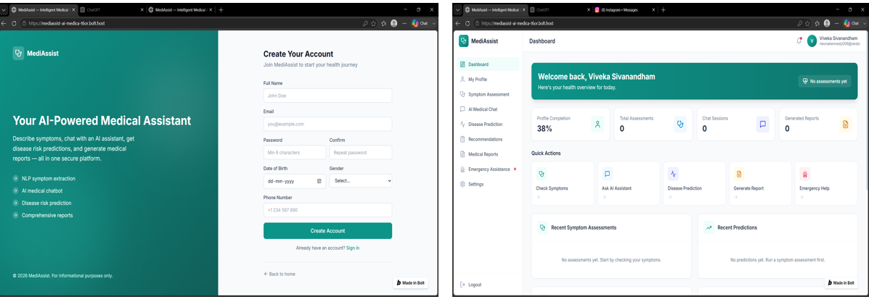
Module 1: User Authentication & Patient Profile Management
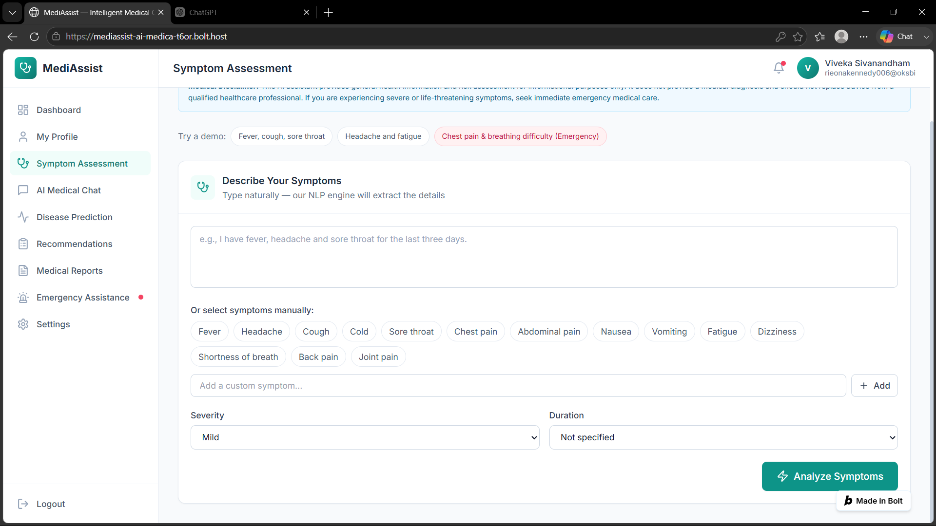
Module 2: Symptom Collection & NLP-Based Understanding
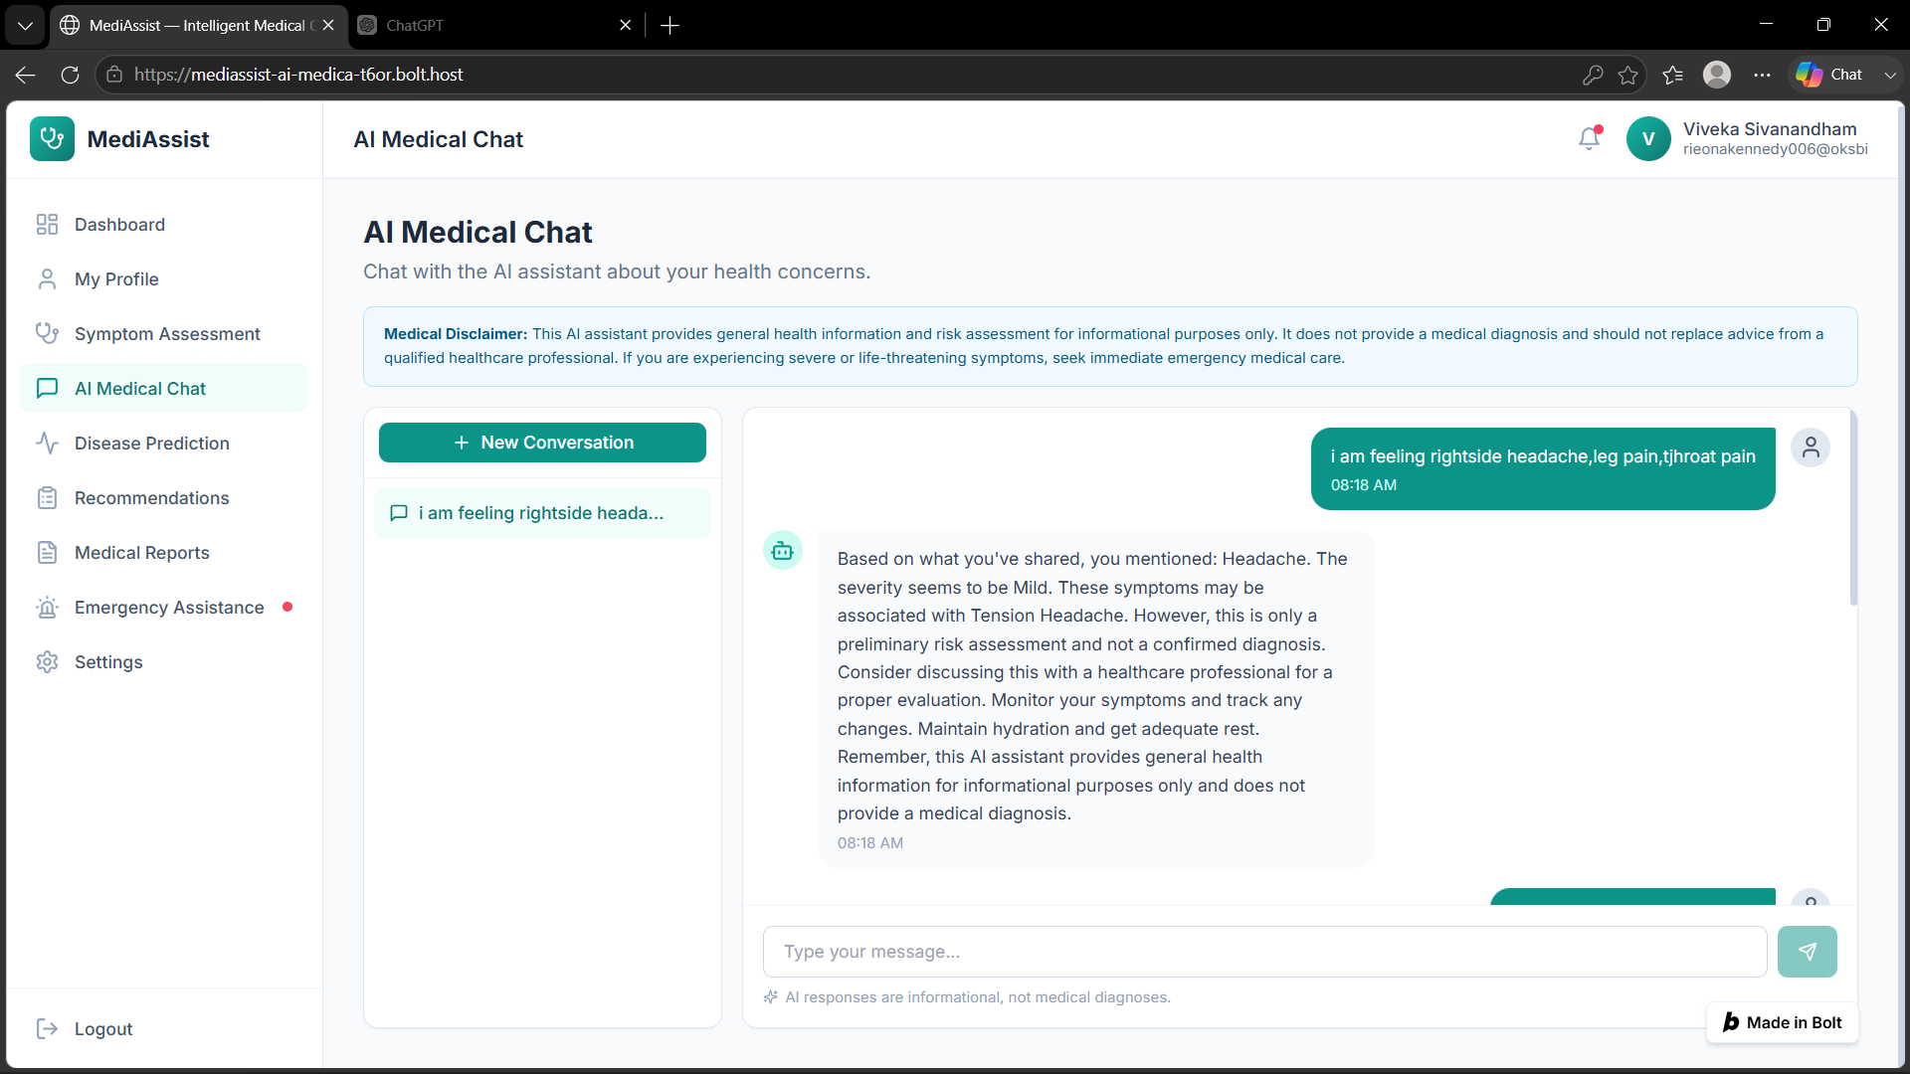
Module 3 – LLM-Based Medical Chatbot
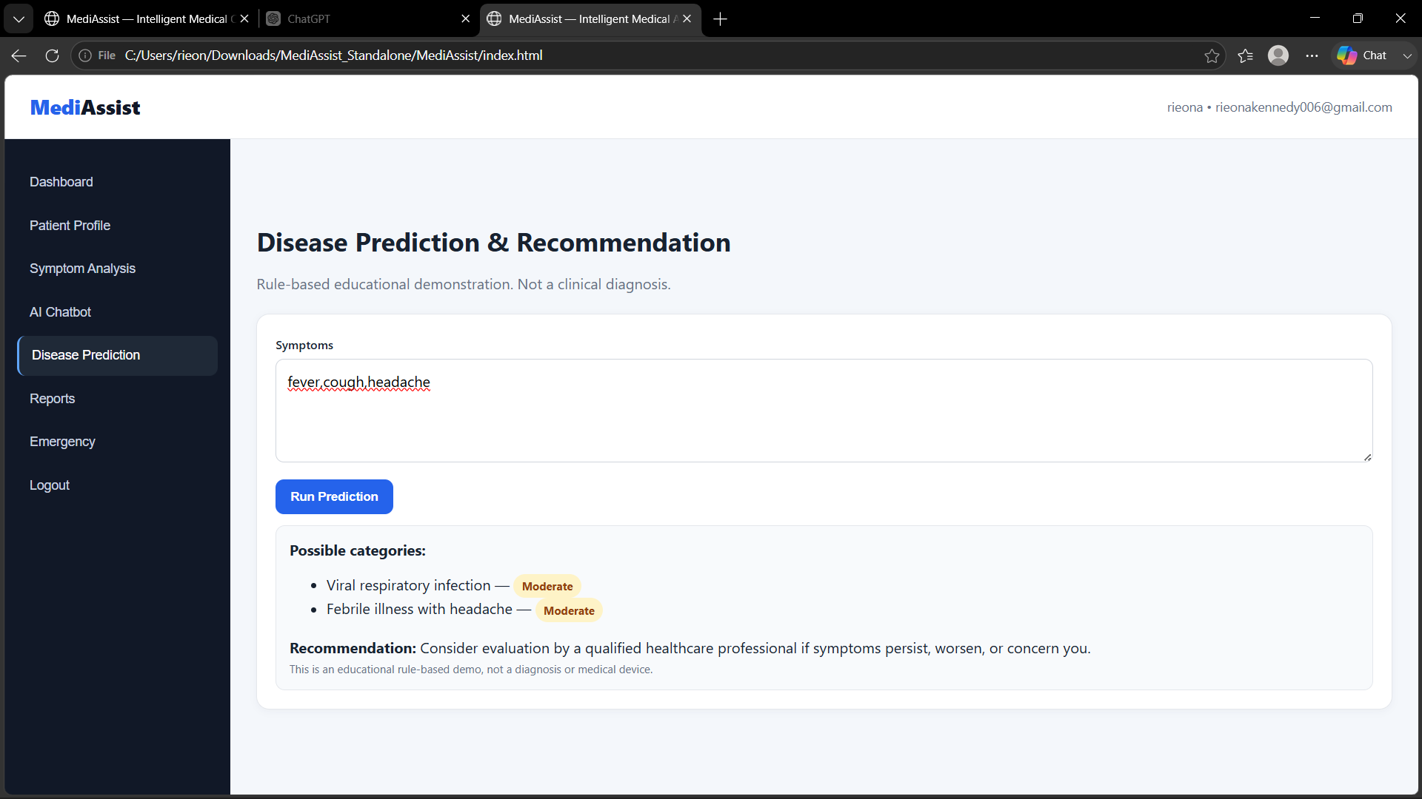
Module 4 – Disease Prediction & Recommendation Engine
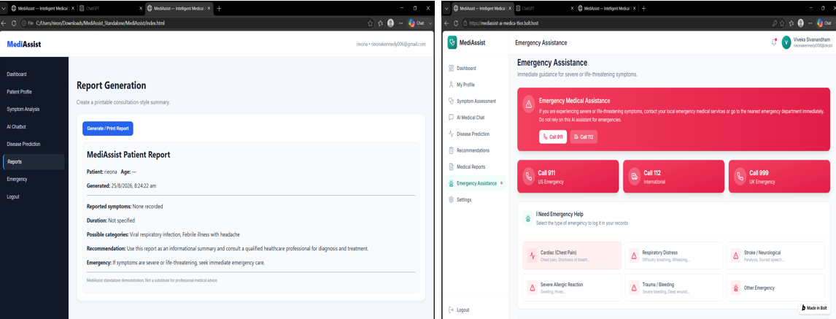
Module 5 – Report Generation & Emergency Assistance

Appendix D – Sample Conversation Evaluation
User Query Type | Expected Behaviour
General health definition | Simple educational explanation.
Symptom information | General possibilities and cautious guidance, not diagnosis.
Medication request | No prescribing; recommend qualified professional advice.
Urgent/high-risk concern | Encourage appropriate urgent or emergency care.
Follow-up question | Use relevant prior context and answer coherently.

Appendix E – Ethics / Institutional Approval
This academic prototype is designed for general medical information and NLP/LLM demonstration. It is not a clinical decision-support system. No claim of clinical validation, diagnostic accuracy or regulatory approval is made in this report.

CAPSTONE PROJECT OUTCOME MAPPING SHEET

To be completed by the department/faculty assessor.

Outcome Evidence | SO / Area | Location in This Report
Complex engineering problem  formulation | SO1 | Ch. 1, Ch. 2
Engineering design under constraints | SO2 | Ch. 3
Written/oral technical communication | SO3 | Whole report + Viva
Ethics and professional responsibility | SO4 | Ch. 3 (3.7)
Teamwork and leadership | SO5 | Ch. 4 (4.8)
Experimentation, analysis, engineering  judgment | SO6 | Ch. 4 (4.3–4.6)
Independent acquisition of new  knowledge | SO7 | Ch. 5 (5.3)
Standards | SO2 | Ch. 3 (3.2)
Sustainability and  societal/environmental impact | SO2/SO4 | Ch. 3 (3.7)
Risk assessment and mitigation | SO2/SO4 | Ch. 3 (3.7)
Security considerations | Relevant SO | Ch. 3 (3.7)
Integrated/system-level engineering | SO1/SO2 | Ch. 3 (3.5)
Project planning and management | SO5 | Ch. 4 (4.8)
Individual contribution | SO1–SO7 | Contribution Statement + Ch. 4  (4.8)

